|  |  |
| --- | --- |
| **Name** | Thomas Whipple |
| **Manager** | Seyed Paransun |
| **Change Request ID** |  |
| **Date Submitted** | 18-February-2016 |

|  |  |  |  |
| --- | --- | --- | --- |
|  | *REASON FOR REVISION/DESCRIPTION OF CHANGE* | *REQUESTOR* | *DATE* |
| B | Added Q&A section, user access, Email and file attachment | Whipple | 09-Mar-16 |
| A | Initial release | Whipple | 18-Feb-16 |

* **Purpose or Problem Definition**

Create a web-based application to accept Engineering Build Request data, and output the form to .pdf form for sending

* **Assumptions, Dependencies, Constraints**

The current Excel-based template form is in Appendix #1.

**Requirements**

* **Business Requirement #1**

The web form should include drop-downs as much as possible based on the Excel template

* **Business Requirement #2**

There needs to be a way for administrators to log in and manage the drop down contents

* **Business Requirement #3**

The system should output a .pdf of a completed form similar to the Excel template

* **Business Requirement #4**

All data should be retained in ACP_REPORTS database

* **Business Requirement #5**

Users should be able to open, create and edit forms multiple times prior to publishing them

* **Business Requirement #6**

Once the State changes on an EBR, an email with a link to the EBR should be sent to the originator and the Planner user level distribution. The EBR ID and Rev should be linkable to the online system

* **Business Requirement #7**

There are 6 states/actions needed to be handled by the system:

Draft

Submitted

Rejected (Action, returns EBR back to Draft, increases REV by 1)

Accepted

Completed

Cancelled (changes column IsDeleted to 1)

Cancelled EBR should be searchable from a simple EBR search form

* **Business Requirement #8**

There should be three levels of users:

1. User
2. Planner
3. Admin

The User can create and submit EBR, view all dashboard

The Planner can edit any draft EBR, and change EBR from Submitted to Reject, Accepted and Completed.

Only Submitted EBR can be Rejected

Only Submitted EBR can be Accepted

Only Accepted EBR can be Completed

ANY EBR can be Cancelled by the originating User, any Planner or Admin (changes column IsDeleted to 1 without changing the state).

* **Business Requirement #9**

REV management:

The REV field must be maintained by the system

New draft are always Rev 01

If Submitted and Planner user level tags as Rejected, save Rev01 as closed with no changes, copy all data into REV02 for the same EBR ID and change status to Draft for the same owner. Emails should also be triggered as per Requirement #6 in this document.

* **Business Requirement #10**

**This requirement overrides Business Requirement #1**

The EBROnline form should be pre-populated with CPN from ACP_REPORTS.vEBR_CPN_LIST.

Once the user enters or selects a CPN from the dropdown, the SL Code field should prepopulate with data from vEBR_CPN_LIST, including a -none- to match as No SL Code Needed.

Once the CPN and SL are selected, the form should pre-populate with the data from vEBR_CPN_LIST. These fields are changeable after they are populated, but we want to put the correct data in initially.

Bạn có thể mô tả chi tiết **Business Requirement #10** được không**?**

* **Business Requirement #11**

The DashBoard should include columns as below:

EBR ID

Rev

Device

Originator

Last Changed By

Last Changed Date

State

* **Business Requirement #12**

The EBR user should be able to upload files and link them into the form from the form

Bạn có thể chỉ rõ những fields nào có thể upload files được không?

Thêm form upload file trong new request [Hung answer]

* **Business Requirement #13**

The EBR Add Lot function window should include options to add up to THREE Stack Die to the Main Lot. The fields to include are StackDieLotid, StackDiePMPN, StackDieQty, StackDieWaferNumbers.

Như bạn mô tả thì 4 field này được them vào form Add Lot cũng với các fields đã tồn tại trước. Hay chỉ là 4 fields này duy nhất trên form.

Thêm 4 fields này vào trong form Add Lot, hiện tại đã có 5 fields, vậy total là 9 fields [Hung answer]

* **Appendix #1**



* **Appendix #2**

**Q&A**

I will develop a web app with:

* Free input fields → will be text boxes. YES
* With fields having comment Price/Comments, FAB Die Revision,… → I will add a short guideline next to the textbox/dropdown YES
* Dropdown selection field → will be dropdown list for user to select value. YES
* 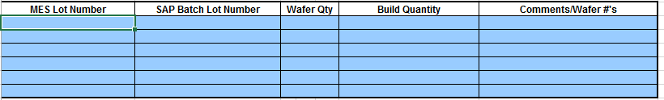

→ this section will be a list view and use will be able to add/edit via a popup, also can delete records inline. YES

Some questions:

1. Use can submit many records (1 record ~ 1 excel file) ? This form is not used a lot, maybe once per week only.
2. Do we need an admin page for user to maintain values in dropdown lists? YES, that’s a good idea
3. Database: I will create new tables in ACP_REPORTS database to save records? YES, table names should begin with EBR_<table function>
4. 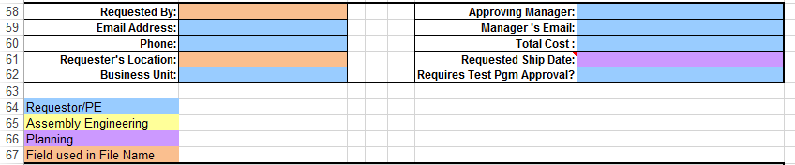

From this section, I found that there’re Requestor info and Approving Manager info. So will we implement a workflow here? For ex: Requestors can submit record to request, Manager will login and approve/reject request which submit to him? Approving manager is just a name input field, not an approval work flow.

If the answer for this question is YES, then we also have the login/logout function. We also implement the filter function (Manager can view request which are submit to him only). No, not a workflow approval. But we probably want user traceability by using a login and filter function for reporting later.

1. 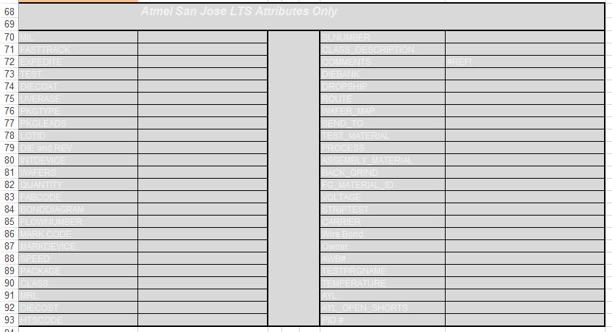

* I’m not understand this section, please help to explain it to me. It’s OK to ignore this section for now, focus on the top and the dropdown management. I will create BRD today.

Thank Tom,

I worked on it already, and the BRD seem to be not different with what I’m implementing. I will continue working on it.

But, there’s some more questions related to Business Requirement #5 need your confirmation:

Users should be able to open, create and edit forms multiple times prior to publishing them

Q1. From my understanding, form owner can create and edit HIS form multiple times if it does not submitted. Is that correct? YES.

Q2. The form will have at least 2 statuses:

* Draft (or something similar): the form created but not submitted. On this status, owner can still edit the form.
* Published: the owner can submit the form. And once the form submitted, he CANNOT edit it any more.
* Is that correct? YES, this is PERFECT.

Q3. User can only VIEW and EDIT his own forms, cannot VIEW or EDIT form created by other users. Once logged in, he can view his form in a list view. Is that OK with you, or we can change a little bit in the permission, allow users to VIEW all forms, and EDIT his form only? Let confirm this. View all anytime, only edit his own. Admin can edit all. Let’s TRACK who performed the last edit and when in the database.

Thanks,

Hung.